**Chapter 12 – LARRY & TAMMY BRAITHWAITE**

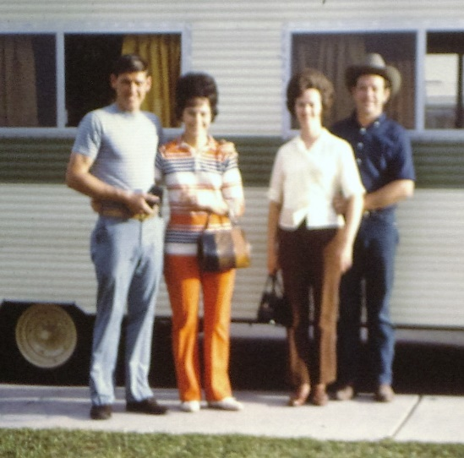**1964 -** **Larry & Tammy Braithwaite** moved into our ward, the Mt Fort Ward in Ogden. They were about our age and Bishop Moulton asked Ken & I to fellowship them as they had been inactive. They had just lost a little daughter in an accident. Larry and his father were contractors. They had a large building framed up and Tammy brought her two girls, Cindy and Lori over to see their dad. A storm came up and one of the big beams fell on Cindy, killing her. Larry & Tammy were devastated. Bishop Moulton had helped them and he wanted us to take over. We did and became best friends. We invited them over for Sunday dinners and they invited us to their home. We took turns eating Sunday dinners at each other's homes and were together a lot other times as well. Sandi & Lori had fun playing together.

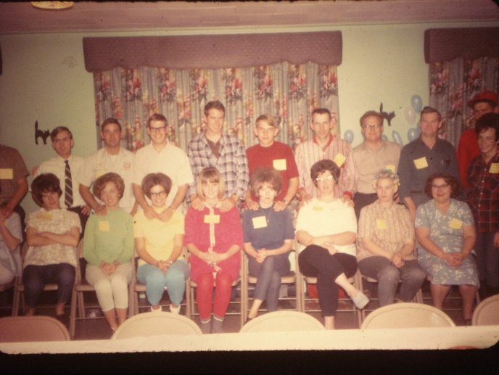Larry & Tammy lived in a nice Trailer in a trailer court in our ward. At that time Ken & I were Young Marrieds leaders. We asked Larry & Tammy to help us. They did a great job and we had fun working together**. Tammy & I had fun as we made up corny verses to put in invitations for Young Married parties, firesides and other activities.** We had good turnouts at our activities and firesides. We didn't limit them to just young marrieds, but all the couples of the ward. **We became good friends with Bob & Pauline Hein and John & Linda Willerton also**. The four couples of us were always at the firesides and activities whether many others came or not - usually there was a good crowd, in fact, most of the couples in the ward. We had "Come As You Are" parties, "Backwards" parties, Progressive dinners, square dances, etc. We went deer hunting with Larry & Tammy. It snowed and was really cold. We pitched a tent for the four of us, but that night I dressed really warm (really funny, but warm) I put on long johns, my flannel nightgown, a sweater, wool scarf, mittens - I guess that's all. Anyway, I looked really funny, but I was warm and that was what mattered. Then Tammy laughed and said to me "you're caught, you have to come dressed this way to our Come As You Are party". Her and I were going around the ward catching people in funny attire to come dressed that way to this party. I had not "caught" her and she had not "caught" me - until then

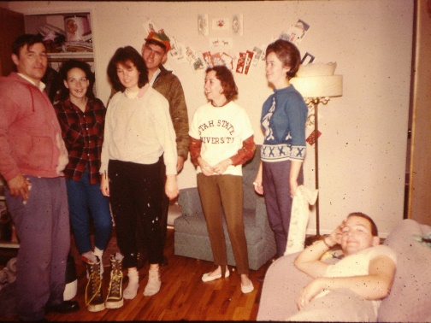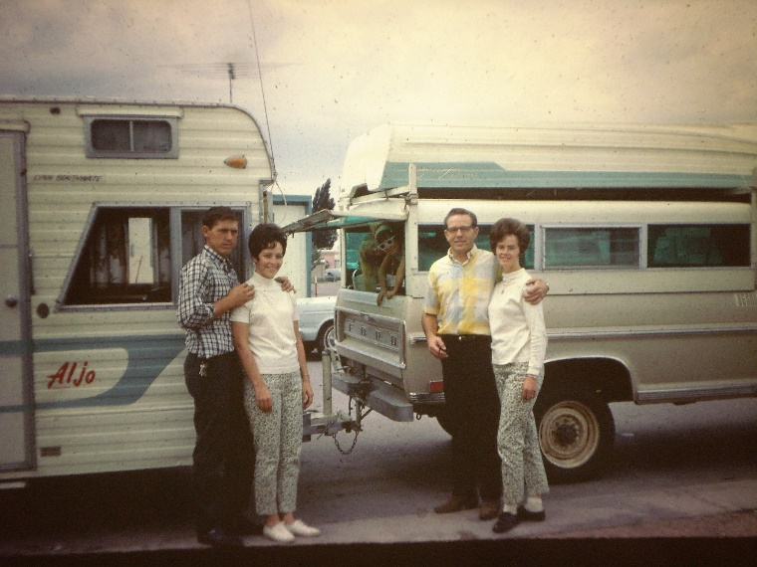Us four couples became good friends and went camping, to the temple, out to eat, played games at each other's homes, etc. After Larry & Tammy moved to Liberty, they invited us up for New Year's Eve and to sleep over and spend the next day riding horses. We went to a New Year's Eve dance together, then went up to Larry & Tammy's. We all had baby sitters for our children. I think Larry's sister was tending their children at her home as they were not at their house. We ate, played games and then tried to sleep a little, but every time we would quiet down and start to go to sleep, Bob would come and squirt water on our faces. We finally all piled on him and tied him up. We've laughed about that many times since. We had a good time riding horses, visiting, eating, etc., most of New Year's Day.

Ken had gotten a job with Commercial Security Bank in their data processing department in Ogden, and he was happy to leave HAFB. He worked here for about four years and then he went into partnership with our friend, Larry Braithwaite, in his construction company. The four of us had become great friends. We seemed to have a lot in common and their other child was Lori and she was the same age as Sandi**,** so they had fun together. Then they had Holly and I had Shellie soon after. They had Lonnie and then Jody. We had Mike, David, Scott & Jeff. Holly & Shellie played together when they were little, Lonnie played with Mike & David. I was pregnant with David and Tammy was pregnant with Jody. I was due a month earlier than Tammy was, but she said “You go two weeks late and I will come two weeks early and we can be in the hospital together.” I told her that it was great for her to come two weeks early, but I didn’t want to come two weeks late. Well, that’s exactly what happened. I went two weeks over and the doctor was going to start me on Saturday. Tammy called me Friday night and said “Mae, I’m on my way to the hospital and I will tell Linda (a nurse who lived in our ward) to save a bed for you next to mine. In those days we didn’t have private rooms, there were four beds in each room, and we stayed for three days in the hospital after having our babies. We had fun together. Tammy had thought she would have a boy and I thought I would have a girl, so we were both surprised. In those days, we didn’t have ultra sound machines, so we didn’t know the sex of the baby until it was born. My doctor, Byron Naisbitt would ask me what I wanted and if I said I wanted a girl, he would say it was a boy. If it was a girl, then I was happy and it didn’t matter what he had said, but if it was a boy, then he was right. Tammy and I became best friends and we were always doing things together and going places together. Tammy & I have always been close, even when our husbands were having problems, we didn't. We always felt we were as close as sisters. The good part was that we didn't fight as some sisters do. We even dressed alike sometimes and people thought we were sisters. Many times, while our husbands were working, her and I would get together and make crafts, work on scrapbooks or picture albums, make Christmas candy together, etc., etc.

As families we would eat at each other’s homes, go to the parks together and have picnics, go camping and fishing together, etc.

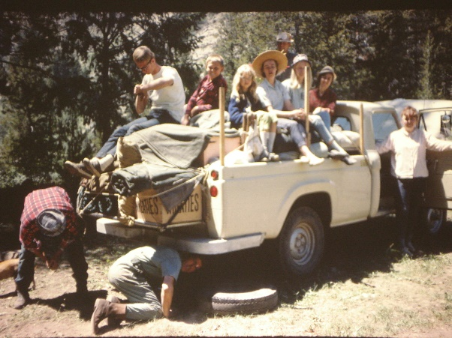

**Jennie’s Lake in Wyoming** – When the children were young, in fact we only had Sandi and maybe Shellie at that time, and Larry & Tammy lived in our ward, we would go with them to Jennie’s Lake in Wyoming to camp and fish. It was a great place to go and we loved being with our good friends. We went there several times. One time we invited the families from our “Ward’sYoung Married Group” and that was fun too. Sometimes we would get a babysitter for our daughters and the four of us would climb in the cab of their truck and go four wheeling up in the mountains. It was always fun.

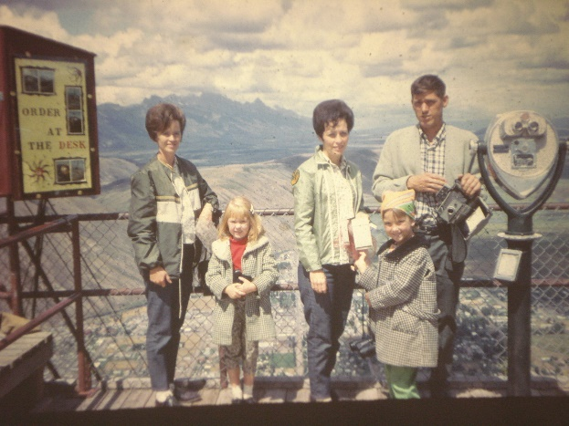The first summer, when Ken & Larry were working together, the four of us took our girls, Sandi & Lori, who were the same age and became good friends, **and went to Yellowstone Park together.** The year was 1966. Larry & Tammy had bought a camp trailer. There had been an earthquake in Montana, close to Yellowstone Park so we went there too. It had devastated that area. We walked onto the roof of a home which had been flooded and carried away. We loved Yellowstone Park and enjoyed being together. We went to a ghost town too and other places. We fixed most of our meals in the camper and we played “Rook” at night after the girls went to bed. That was the time when we stopped wanting to play Rook with them as Larry began outbidding everyone even though he knew he had a bad hand as he thought the odds of winning were good and he always wanted to control the bid. Many times he went under, but he didn’t care, he would still keep outbidding us, so that was no fun for the rest of us any longer. I think that’s the last time we played Rook with him. The girls had fun together. We stopped on the way home at the Idaho Falls Temple and took pictures.

Ken didn’t like working for Perk Petersen because he couldn’t trust him. He would say one thing and do another. We had a hard time getting our pay check and when we did, it usually bounced. Perk didn’t keep track of his money, and would write out checks and didn’t know there wasn’t money to clear them. This happened time after time until Ken finally quit and went to work for Modular Construction Company at Free Port there in Clearfield.

At this time Larry and Tammy had purchased some land in Liberty (up above the dam at Ogden Canyon) to build their home on and have some animals. We figured we would trade our equity on our home in Ogden for some land in Eden (close to Liberty). Ken and Larry figured to help each other build their homes. We talked with the man about the land and had papers drawn up. We moved out to Clearfield to Uncle Dale and Aunt Esther’s old home to rent until we figured we could move into our new home in Eden. After we were moved this man figured he had us over a barrow with us out of our home so he backed out of the agreement - didn’t want to give us what we had asked out of our home on the land. He also wanted us to pay closing costs, etc. We couldn’t afford to do this. Like dumb bells, we didn’t have him sign a contract. We talked to a lawyer and he advised us to just let it drop and sell our home to someone else. We tried to, but were having difficulty so decided to rent it for awhile. That was a big mistake as the couple who rented it just they just had a couple of children and no pets. Well, soon after they moved in, other family members moved in with them and they had several pets. They didn’t take care of the house or yard and, in fact, wrecked the place. It wasn’t long until the neighbors called complaining about these people. They didn’t pay the rent either, so we tried to evict them, but it wasn’t that easy as they had small children. We took them to court, but they didn’t show up, so the judge awarded the case to us. Ken asked him what that meant and he said we had the right to collect it from them. Wow! That wasn’t helpful. Finally, the gas company called us to tell us that the gas bill hadn’t been paid and they were going to shut off the gas. The power company said the same, and we told them both to go ahead and shut off the utilities. It wasn’t long until those people moved out. But, we sure had a mess to clean up and replace carpet, screen door, repaint, redo the lawns, etc. We even found a partially dead cat in a sack in the garbage. We heard it moving around and thought it might be a rat. When Ken took it outside and shook it out, he was mad. They had kicked the cat, broke it’s back and put it in the sack to die. Wish we could have reported them to the humane society.

Ken & I have been emotional a lot lately as we have experienced several hard things in our life over the past few weeks.

- The hardest was to learn of our best friends**, Larry & Tammy Braithwaite's apostasy from the church** and their excommunication. It has really been hard dealing with that. Just about everything we hear, read or see that has anything to do with the church, family or even life makes us think of them and what they have given up and what they are doing. We love them. They have been a big part of our life. We have many fond memories of them. Our last move to Arizona ended in bad feelings from Ken towards Larry and that was hard because Tammy was my best friend and I felt so close to her and I loved Larry also. I didn't agree with all he said or did either, but was willing to forgive him - but Ken wasn't. He has now, thank goodness. They got involved in anti-Mormon literature, they had let down their guard. We don't think they were reading the scriptures, etc., they began to criticize the leaders and find fault - and went downhill from there. We are so sad. We have sent letters and articles, etc., to try to get them to reconsider, and have born our testimonies to them, but it didn't do any good. Finally Larry sent a long letter telling us not to send any more testimonies - that he would never come back in the church. He also sent anti-Mormon literature and a copy of the letter he sent his kids. I threw them away as I didn't want to read them. He said he does love us and wants to stay friends.

I haven't heard from Tammy. Larry has always been the one to talk to us on the phone or write the letters. I wish I knew how she felt. I had called two weeks before we got the terrible letter and had a good visit on the phone with both of them. They never mentioned anything about their leaving the church. I had invited them to come up where we would be camping - up Cedar Canyon with our family on the 8th of August and to invite their family to come also. We hadn't been together with our families since we moved from Arizona the last time. They talked like they would love to come, but when we got the letter they explained that they would love to come and be with us, but maybe we had better do it another time. When we talked with Larry after getting the letter, we asked about his children. He said some are OK with it and had doubts too, that Lonnie & his wife were upset at first, but now had confessed that they have doubts too, but since her family are strong active members that they won't leave the church as it would be too hard on her parents. He said Jody is having the hardest time - that she said "Dad, why have you spent all my life teaching me the gospel and telling me it was true and now you tell me it isn't". Ken & I really feel bad for their children. I'm sure it is tearing them apart. Ken & I feel so bad and they are always in our thoughts and prayers.

**2017 – update on Tammy & Larry**

We had heard from Shellie that Larry & Tammy’s son, Lonnie and his wife & children live in their stake in Queen Creek, Arizona. She saw him & his wife at the temple and they were excited to see each other and catch up on our families. Lonnie told Shellie that he and his family can’t have contact with his parents as Larry is so anti Mormon that he tried to get Lonnie to leave the church. Lonnie wouldn’t do it and so Larry wouldn’t let him talk to his mom. He told Shellie that his mom is a wonderful grandmother, but she can’t be a grandmother to his kids because every time he would go to their house, his dad would keep telling him anti Mormon stuff and so they haven’t been able to go there. Lonnie was in the High Council, in the Bishopric and works in the temple. Lonnie’s wife has always been strong in the church and they are raising their children in the gospel. As far as we know Jody is still active too, however, she divorced her husband. He is a good man and they have had leadership positions also, but Tammy told us lately that they just were not compatible. She is dating a guy she dated in high school, who is also divorced. Lori and her husband are messed up, and Lonnie said Holly is Holly. She was always scatter brained. She has been married and divorced two or three times and her husband was unfaithful to her, so she was unfaithful to him.

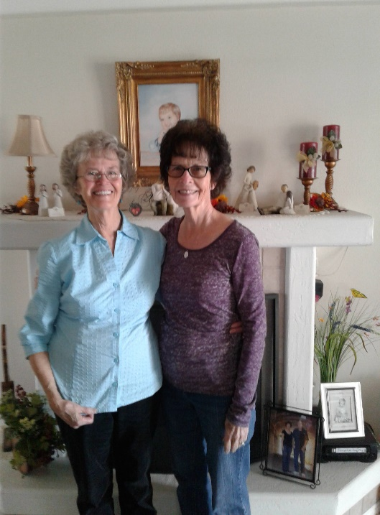Our son, David, had Lonnie’s married son, who lives in this area, come to him as a patient and David found out that he was Larry’s grandson. This grandson recently called David to let him know that Larry had passed away. On our way to Shellie & Roy’s home in March, we stopped at Maggie & Bill Klass’s home to visit and spend the night with them. They were good friend from when we had our home in Layton and they recently moved to St. George. We had **Tammy’**s home address, so we decided to go see if she was home to visit her for a few minutes, the next morning before we went on our way to Shellie and Roy’s home. She was home and when she opened the door and saw us, she was so surprised and then gave me a big hug and we cried as we hugged. She hugged Ken also and then invited us in. We visited for a while and she told us about the “Celebration of Life” they had for Larry and how she was so thrilled that over 80 people came. She said lots of neighbors and friends loved Larry. We loved him also as he was a good and generous man – just wish he hadn’t listened to Satan and left the church. Anyway, she showed us the beautiful sunroom he made for them and a couple of beautiful chests he made and she painted. They were beautiful. Larry was a special craftsman, he was really talented. Larry died of Rumatoid Arthritis. He came down with it soon after we met them and it kept progressing. He really suffered with it, but he didn’t let it stop him, until it finally got him in the end. Tammy said the last year or so he showed her all the things she needed to know to take care of their home and yard – so that was great. I have always loved Tammy like a sister and it was so good to see her again. I don’t know if we will ever be close again like we were, but I was thankful to see her again